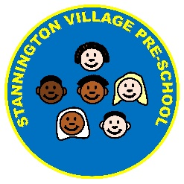
Parental Covid-19 Declaration

At SVPS we are working to put systems in place that will ensure that our environments are safe places for both your children and our staff. We will need your assistance to ensure that we are able to maintain our safe learning environments.
We, therefore, ask that you complete and return the form below which outlines particular activities that will help to keep our setting safe
Please confirm the following: | Yes | No
- I and the adult members of my household are aware of the symptoms of coronavirus (COVID-19).
- I and the adult members of my household are aware of the need to self-isolate should anyone experience the symptoms of coronavirus.
- I will notify SVPS as a matter of urgency should someone in my household become symptomatic / be contacted by Track & Trace / receive a positive test result
- I understand that I will not be able to bring my child to SVPS if my child wakes with a temperature and I feel that it is necessary to reduce their symptoms by giving, for example, Calpol or any other products which contain paracetamol or ibuprofen.
- I understand that I will be asked to keep my child at home for a minimum of two weeks should my child develop some of the coronavirus symptoms unless a negative test result is obtained.
- I and adult members of my household commit to following the social distancing guidance issued by the Government.
- I understand that should coronavirus cases occur within the SVPS staff or children it may be required to close temporarily by Public Health England for a quarantine period.
- I understand SVPS may be required to share information as part of Track & Trace requests.
I authorise such disclosure as long as it complies with GDPR requirements.

Childs Name: | Address | Date of birth
Parent/Carers name | Address if different to that above
Telephone number

Signature  Print name |  | Date

