**Spring Newsletter**

[](https://www.google.co.uk/imgres?imgurl=https%3A%2F%2Fwww.brighteyescornwall.co.uk%2Fwp-content%2Fuploads%2F2017%2F02%2FEYFS-pic.jpg&imgrefurl=https%3A%2F%2Fwww.brighteyescornwall.co.uk%2Fearly-years-learning-town%2F&docid=Fp6JBTLxz6hjwM&tbnid=IZtnhA8C6FqgRM%3A&vet=10ahUKEwipptfhnbXnAhWDoXEKHUY9CWwQMwh6KAAwAA..i&w=480&h=319&bih=655&biw=1366&q=early%20years&ved=0ahUKEwipptfhnbXnAhWDoXEKHUY9CWwQMwh6KAAwAA&iact=mrc&uact=8)**Stannington Village Pre School**

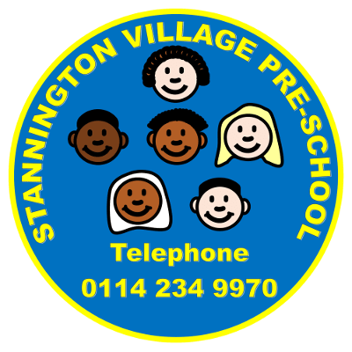

**Events**

* Stay and play – Thursday 27th February 9:15am – 10:00am
* Stay and play – Monday 16th March 9:15am – 10:00am

We would like to thank all families and children for continuing to help make SVPS a wonderful Pre School and the support we receive is always appreciated.

Please keep a look out for our announcements of village and community walks that we would love if you could all join us.

Sarah and the SVPS team xx

**PLACES FOR SEPTEMBER 2020**

**Although we are only approaching the end of Spring Term 1 it is never too early to start and think about your child’s hours for September. Intake has been fantastic this year and we are now operating at full capacity. Please come and speak to myself (Sarah A) and we can book sessions in for your children for the new academic year.**

Since returning in January we have been asking families to bring a pair of indoor shoes/slippers for each child to wear in the Pre School room. Majority of parents have now done this but we still have some children entering Pre School in outdoor shoes. Please can you help support the cleanliness of Pre School by providing indoor shoes to keep our room safe and clean, especially during the wintery wet months. There is a purple tub basket in the entrance where indoor shoes can be stored if you wish to leave them here.

If your child is potty training please ensure you are sending plenty of spare clothes in case of accidents, easy pull up and down trousers such as jogging bottoms and leggings help support the children to be independent when training also.

We have a lot of drinks bottles that are the same, this is making it difficult for us to identify each child’s bottle. Please support us in adding a label to your child’s water bottle so we can easily identify each child’s individual bottle.

Thank you x

**Holiday dates for the calendar, please note Pre School will be closed on the following dates:**

Monday 17th – Friday 21st February

Monday 30th March – Friday 10th April

Friday 8th May

Monday 25th May – Friday 29th May

The last day of the academic year will then be Friday 17th July 2020.